|  |
| --- |
| **A**  **SOFTWARE REQUIREMENT SPECIFICATION**  **ON**  **WEB BASED MOOC DETAILS MANAGEMENT SYSTEM**  **UNDER**  **NON-SYLLABUS PROJECT**  **DEPARTMENT OF COMPUTER ENGINEERING SESSION 2022-23**  **SUBMITTED BY:**  **JUHI KALRA (PIET21CS086)**  **KASHISH BARDEJA (PIET21CS092)**  **SUBMITTED TO:**  **DR. SHIKHA GAUTAM**  **ASST. PROFESSOR**  DEPARTMENT OF COMPUTER ENGINEERING  POORNIMA INSTITUTE OF ENGINEERING & TECHNOLOGY, JAIPUR  (ACADEMIC YEAR 2022-23) (ODD) |

**LIST OF CONTENT**

|  |  |  |
| --- | --- | --- |
| Chapter 1 | 1. Introduction of the Project    * + Objective of the Project      + Types of Users      + Dependency      + Methodology Used | 1-3 |
| Chapter 2 | 1. Requirements    * + Functional Requirements      + Non-Functional Requirements      + Technology Used      + H/W Configuration      + Graphical User Interface | 4-5 |
| Chapter 3 | 1. Design    * + DFD      + UML | 6-7 |
| Chapter 4 | 1. Conclusion | 8 |
| Chapter 5 | 1. References | 9 |
| Chapter 6 | 1. Snapshots of the Project | 10-11 |
| Chapter 7 | 1. Code | 12 |

|  |
| --- |
| **DECLARATION**  I hereby declare that the Non-Syllabus Project report entitled “**WEB BASED MOOC DETAILS MANAGEMENT SYSTEM**" was carried out and written by me under the guidance of **DR. SHIKHA GAUTAM,** Assistant Professor, Department of Computer Engineering, Poornima Institute of Engineering and Technology, Jaipur. This work has not been previously formed the basis for the award of any degree or diploma or certificate nor has been submitted elsewhere for the award of any degree or diploma.  PLACE: JAIPUR  **JUHI KALRA (PIET21CS086)**  **KASHISH BARDEJA (PIET21CS092)**  DATE: |

**CHAPTER 1**

**INTRODUCTION**

* 1. **OBJECTIVE**

Hostel Management system is the system that manages the student data, staff data, students admission process and create receipt for the fees paid by the student who stay in the hostel and also help in maintaining visitor’s messages.

This system is designed in favour of the hostel management which helps them to save the records of the students about their rooms. It helps them from the manual work from which it is very difficult to find the record of the students and the mess bills of the students, and the information of about the those ones who had left the hostel.

We design this system on the request of the hostel management, through this they cannot require so efficient person to handle and calculate the things. This system automatically calculates all the bills and issued the notifications for those students who are against some rules. Through this it’s possible to check the personal profile of all the current students within fraction of seconds.

* 1. **TYPE OF USER**
* User Admin
* Login Admin

**1.3 DEPENDENCY**

* There will only be one administrator.
* The edit operation is only available to administrator.
* The login Id and password must be created by system administrator and communicated to the concerned user confidentially to avoid unauthorized access to the system.
* Registration process will be open only for specific duration.

**1.4 METHODOLGY**

**WATERFALL MODEL:**

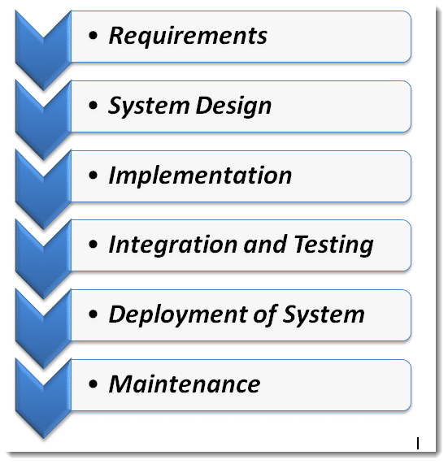



* **Requirements:**

The first phase involves understanding what needs to design and what is its function, purpose, etc. Here, the specifications of the input and output or the final product are studied and marked.

* **System Design:**

The requirement specifications from the first phase are studied in this phase and system design is prepared. System Design helps in specifying hardware and system requirements and also helps in defining overall system architecture. The software code to be written in the next stage is created now.

* **Implementation:**

With inputs from system design, the system is first developed in small programs called units, which are integrated into the next phase. Each unit is developed and tested for its functionality which is referred to as Unit Testing.

* **Integration and Testing:**

All the units developed in the implementation phase are integrated into a system after testing of each unit. The software designed, needs to go through constant [software testing](https://www.toolsqa.com/software-testing/software-testing/) to find out if there are any [flaws or errors](https://www.toolsqa.com/software-testing/istqb/error-defect-failure/). Testing is done so that the client does not face any problem during the installation of the software.

* **Deployment of System:**

Once the [functional and non-functional testing](https://www.toolsqa.com/software-testing/functional-and-non-functional-testing/) is done, the product is deployed in the customer environment or released into the market.

* **Maintenance:**

This step occurs after installation and involves making modifications to the system or an individual component to alter attributes or improve performance. These modifications arise either due to change requests initiated by the customer, or defects uncovered during live use of the system. The client is provided with regular maintenance and support for the developed software.

**CHAPTER 2**

**REQUIREMENT ANALYSIS**

**2.1 FUNCTIONAL REQUIREMENTS**

1. User shall generate the users profile containing the following information-users id, name, address, phone no and room no.

2. User will allocate rooms to students according to the session or class.

3. User must allow to put hold on a room if any room is not available at the moment.

4. User will allocate rooms to students according to the batch or class.

**2.2 NON-FUNCTIONAL REQUIREMENTS**

1. Availability

2. Security

3. Scalability

4. Maintainability

5. Reliability

* 1. **TECHNOLOGY USED**

1. MS-Windows Operating System

2. HTML, CSS, Bootstrap, JavaScript for designing front-end

3. MYSQL for backend

4. PLATEFORM: PHP LANGUAGE

**2.4 HARDWARE SPECIFICATION**

1. Screen resolution of at least 640 x 480 or above.

2. Support for printer (dot matrix, desk jet, LaserJet)

3. Computer systems will be in the networked environment as it is a multi-user system.

4. At least 1 GB RAM and 16 GB space of hard disk will be required to run the software.

**2.5 GRAPHICAL USER INTERFACE**

The Hostel Management System will have following user-friendly and menu driven interfaces

1.Information: information about hostel is completely given.

2.Register: to register himself/herself to the system.

3. Login: to allow the entry of only authorized users through valid login Id and password.

4. User Details: to maintain user information.

**CHAPTER 3**

**DESIGN**

**3.1 DFD**

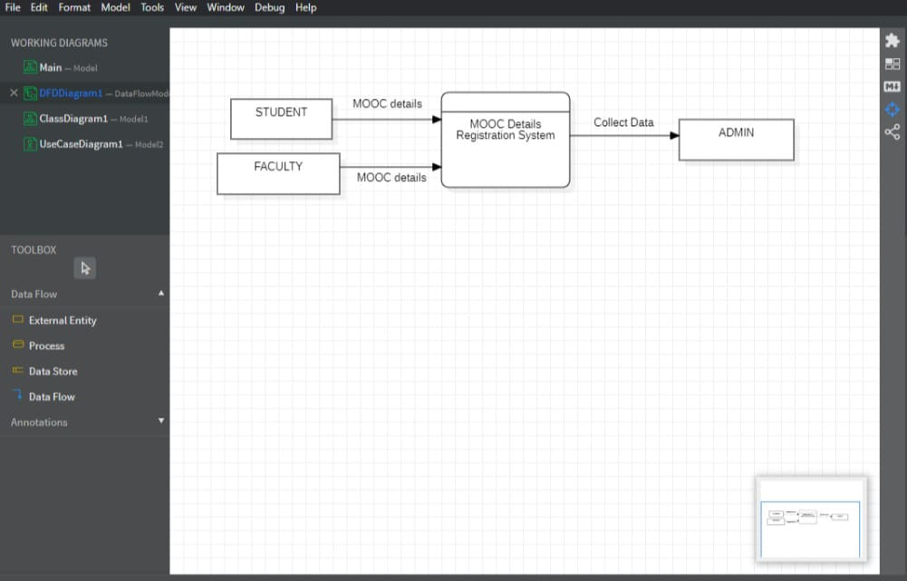

**3.2 UML**

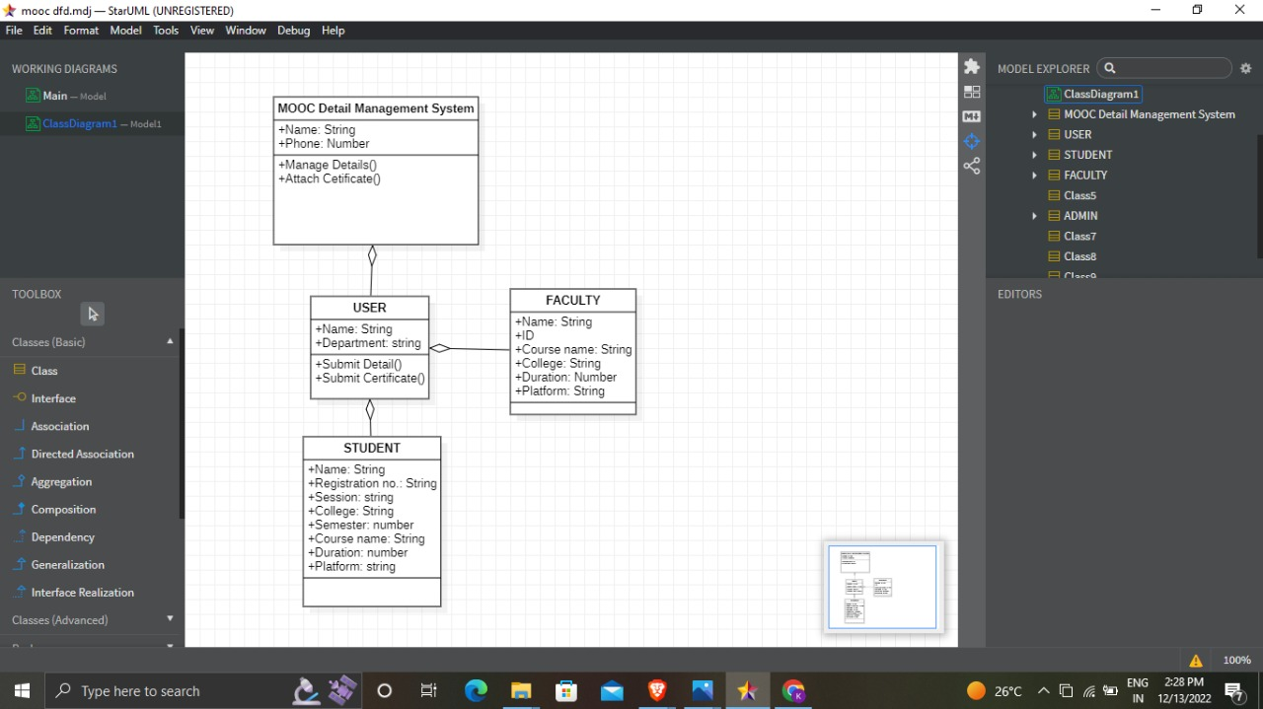

**CLASS DIAGRAM**

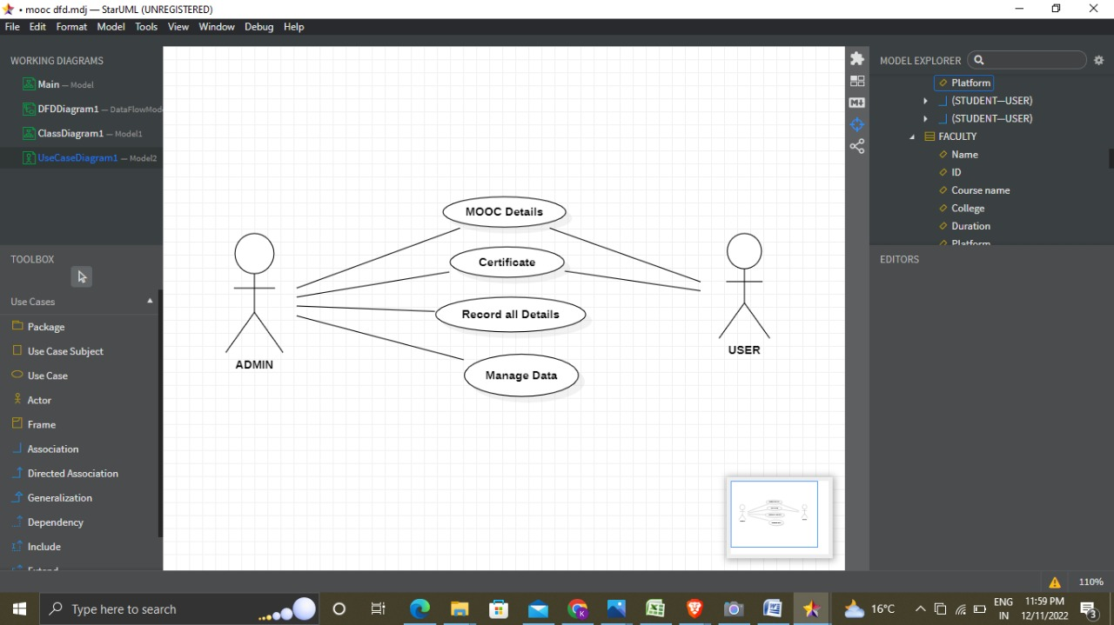

**USE CASE DIAGRAM**

**CHAPTER 4**

**CONCLUSION**

Our project **“WEB BASED MOOC DETAILS MANAGEMENT SYSTEM”** is a very helpful and important project that will help in collecting data from user like students and Faculties. The scope of this project is to provide facility to an organisation to collect information from its users about their Massive Open Online Courses they have done. Our project enables the organisation to gather data like name, registration number, name of the platform, course duration, credits, certificate,etc. from the user. This management system will be an error-less or bugs free management system and will be able to show the records of even years without any confliction.

**CHAPTER 5**

**REFERENCES**

* **https://www.geeksforgeeks.org/html-introduction/**
* **https://www.geeksforgeeks.org/css-introduction/ •**
* **https://getbootstrap.com/ •**
* **https://stackoverflow.com/ •**
* **www.programiz.com •**
* **https://github.com/ •**
* **https://www.w3schools.com/ •**
* **www.google.com**
* **www.wikipedia.com•**

**6**

**CHAPTER 6**

**SNAPSHOTS OF PROJECT**

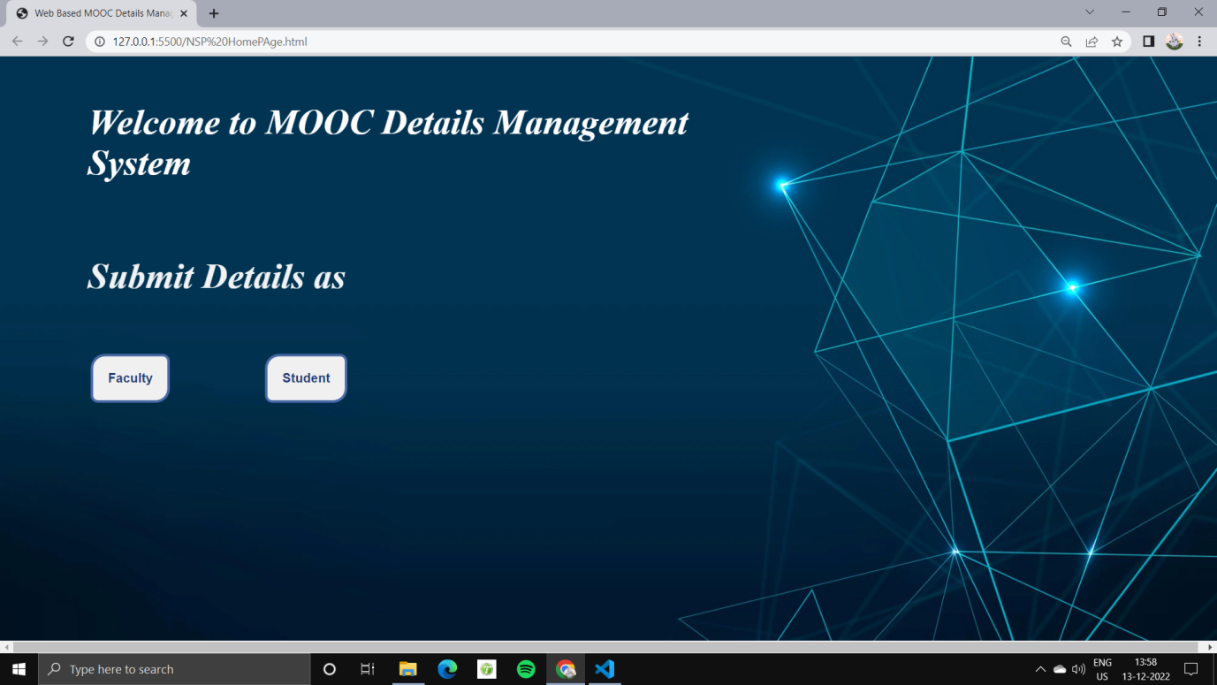

**HOME PAGE**

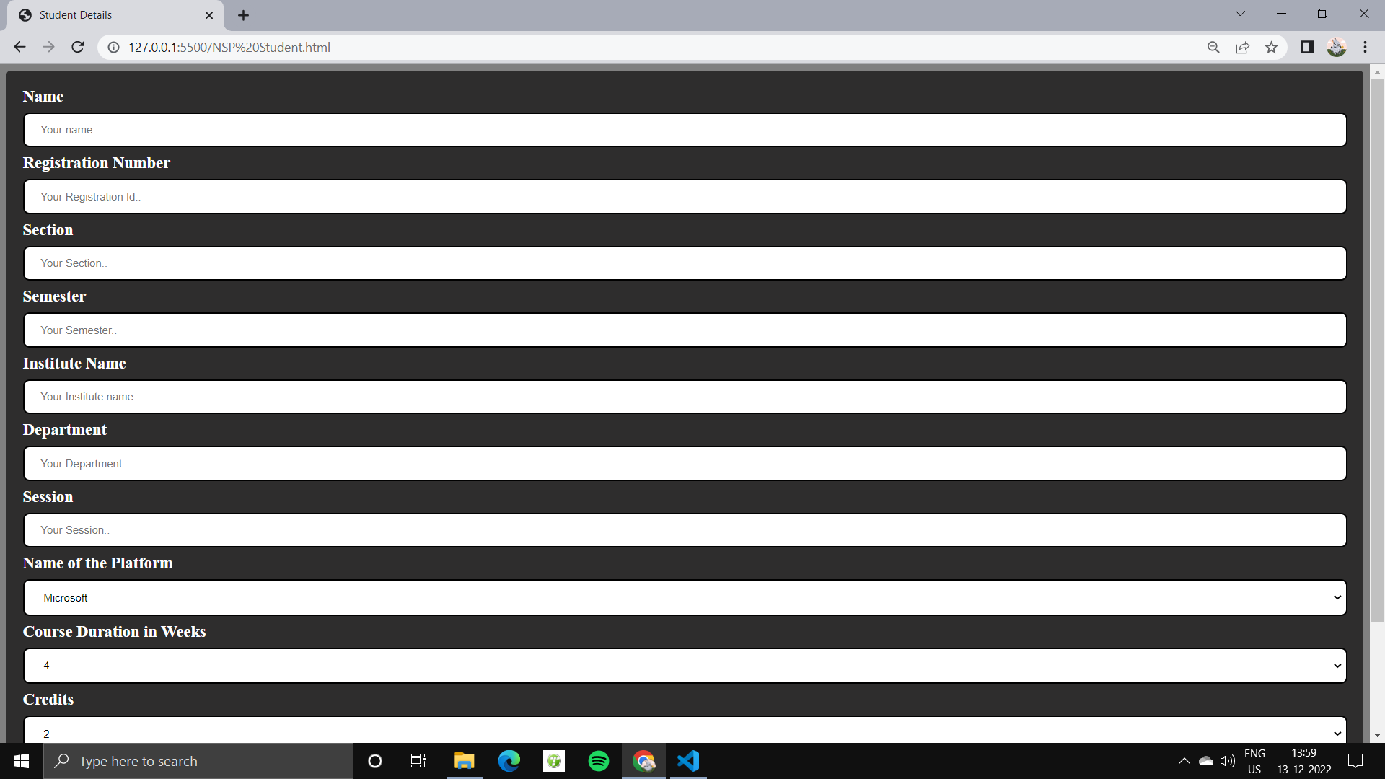

**STUDENT FORM**

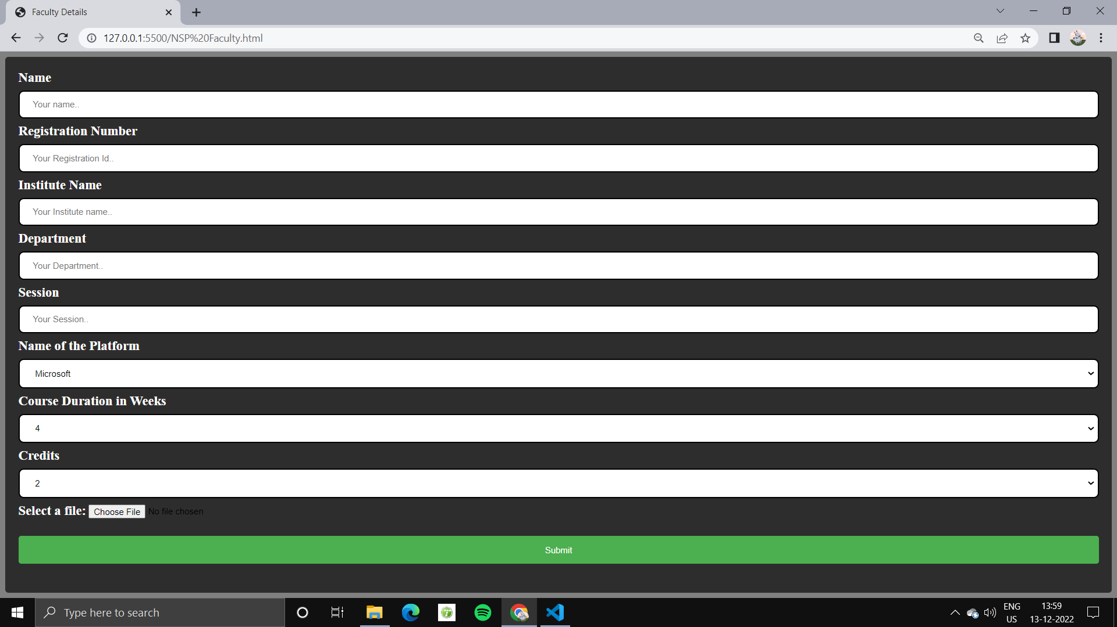

**FACULTY FORM**